

FCCPS AI Advisory Committee
  - Values and Principles - Committee Guidance Packet
Version: Draft for Form 1 rollout

Figure 1. Values and Principles workflow (F1-F6).
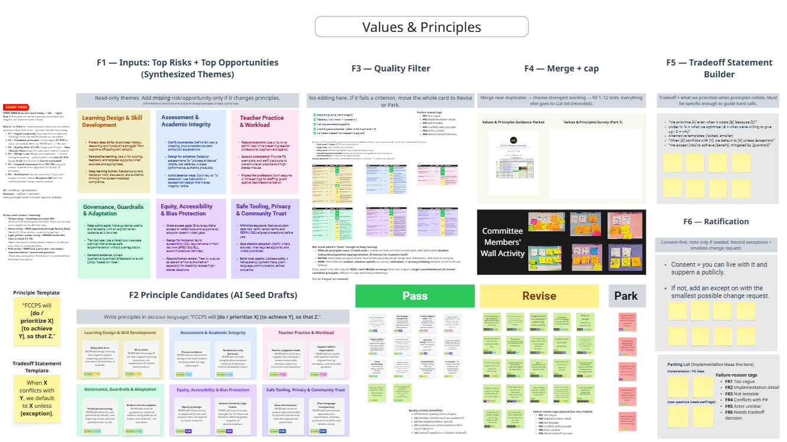

Purpose and what you are being asked to do
This packet explains the committee's Values and Principles workflow (F1 through F6), how it builds on our Team Formation and Shared Baseline work, and how you can provide structured input through Form 1 and a follow-on Form 2. The goal is to produce a small set of board-ready policy principles and at least one tradeoff statement that can guide drafting, implementation planning, and the risk register.

What you will complete
- Form 1: Approve or propose revisions to the F3 candidate clauses, tag tensions using TR codes, and choose options on key tradeoffs (T1-T7).
- Form 2 (later): Select and cap the final merged principle set (8-12) after wording is finalized.

What you will receive after Form 1 closes
- A change log (what changed and why).
- A merge map (which approved clauses were absorbed into which seed principles).
- A vNext set of merged, board-ready principles plus a primary tradeoff statement (and a backup, if needed).
- A short Form 2 to confirm the capped set.

How this work connects to Team Formation and Shared Baseline

Team Formation
Team Formation created workstreams and assigned leads/co-leads so the committee can translate principles into coherent policy domains (instruction, assessment, equity, privacy/security, governance, communications, and implementation supports). This protects the process from single-lens dominance and ensures each domain has accountable owners for follow-through.

Shared Baseline
Shared Baseline work established common definitions, assumptions, and a shared picture of classroom realities and key claims/concerns we must address. These baseline outputs inform what should appear in F1 (risks/opportunities), what 'quality' means in F3, and what tradeoffs must be made explicit in F5.

End-to-end workflow: F1 through F6
The Values and Principles workflow moves from synthesized inputs to board-ready principles with explicit tradeoffs and a consent-based decision record.

Workflow map (inputs, activities, outputs)
Step | Purpose | What happens | Output artifact
F1 - Inputs | Define the problem space | Review synthesized top risks and opportunities (read-only themes). | F1 theme set
F2 - Candidates | Generate candidate principles | Use AI seed drafts plus human write-ins in decision language ("FCCPS will..."). | F2 candidate set
F3 - Quality filter | Make candidates board-ready | Pass / Revise / Park using a shared checklist; record failure reasons. | Pass/Revise/Park piles
F4 - Merge + cap | Create a usable set | Merge near-duplicates and cap to 8-12 principles; keep a cut list. | Merged principle set + cut list
F5 - Tradeoffs | Handle collisions explicitly | Draft 1 primary tradeoff statement (plus 1 backup) for collisions. | Tradeoff statement(s)
F6 - Ratification | Make decisions durable | Consent-first ratification; record exceptions and smallest-change requests. | Consent record + exceptions

Non-negotiables that keep us moving (enforced quietly)
- Humans move cards. AI suggests; committee decides.
- No Pass without sponsor initials (or a named sponsor in the form).
- Use the 20-second rule in live review: if not resolvable quickly, move to Revise.
- Avoid wordsmithing in F3/F4; aim for smallest edits that fix the quality issue.
- Nothing is lost: Park and Cut lists preserve ideas for later implementation planning.

Why this milestone matters for workstreams and the risk register
Adopted principles and tradeoff statements serve as a checkpoint that allows workstreams to converge. Without a stable principle set, parallel drafting tends to diverge, producing contradictions, gaps, and late-stage rewrites.

How principles guide workstream convergence
- Each workstream can map draft guidance back to specific principles (traceability).
- Principles create common language for domain decisions (for example: what 'high-stakes' means, when disclosure is required, and what is prohibited by risk).
- Tradeoff statements provide a default posture when principles collide, reducing inconsistent decisions across workstreams.

How principles connect to the risk register
- Risks are recorded as: risk category related principle(s) default posture (tradeoff statement) mitigations/guardrails evidence/monitoring ownership.
- This structure turns risk discussions into actionable policy controls and monitoring commitments.

How we will complete the work from where we are now

Current status
In the meeting, we completed AI seed drafting and an initial F3 quality filter pass. The next step is to collect committee input on wording and tradeoffs through Form 1, then finalize merged wording and cap the set through Form 2.

Two-stage approach
- Form 1 (this round): approve or propose revisions to candidate clauses and select options for key tradeoffs.
- Facilitation synthesis: consolidate approvals, resolve conflicts with smallest-change edits, and build a vNext merged set plus tradeoff statement(s).
- Form 2 (follow-up): select and cap the final merged principle set (8-12) and confirm tradeoff statement(s) if needed.
- Ratification: record consent and any exceptions.

How to respond in Form 1

F3 candidate sections: approve or propose revised text
- Approve: accept the clause as written (it will be merged into the stated seed principle if a merge target is listed).
- Do not approve: propose alternate wording using the required format and keep it to one sentence.
- Select up to 3 TR codes to indicate which decision lenses are in tension for this clause.
- Use the comment box for boundary conditions or examples, not for full rewrites.

Proposed revision format (required when you do not approve)
Use this format in the Proposed Revision box:
- Heading (sentence case).
- FCCPS will ... (one sentence; clear actor + scope + constraint).
- Optional: suggested merge target.

TR codes: decision lenses (select up to 3)
TR codes help us summarize what the tension is about and maintain traceability.
- TR1 - Learning impact and deep skills
- TR2 - Assessment validity and academic integrity
- TR3 - Equity, accessibility and inclusion
- TR4 - Privacy, security and data minimization
- TR5 - Student safety and developmental appropriateness
- TR6 - Transparency, accountability and community trust
- TR7 - Feasibility, workload and sustainability
- TR8 - Evidence, monitoring and reversibility

Tradeoff statements (T1-T7): choose an option and tag the lenses
- Pick Option A, B, or C (or select Need more info).
- Select up to 3 TR codes that explain why you chose that option.
- Use the comment field to propose a guardrail, exception, or hybrid condition.

What happens after Form 1 closes
- We compute approval rates and triage disapprovals by dominant TR lens.
- We consolidate competing edits using smallest-change, decision-language rewrites.
- We produce a vNext merged set (8-12) with a cut list and a merge map.
- We draft 1 primary tradeoff statement (plus 1 backup) grounded in the most contested collisions.
- We publish a short change log before sending Form 2.

How to respond in Form 2
- Review the vNext merged principle set and select up to 12 items for the capped list.
- Optionally identify your top 3 priorities.
- Confirm tradeoff statement(s) if the committee remains split after Form 1.

Why this approach increases validity and traceability

Validity
- Stage separation prevents premature convergence: generation (F2) is separated from screening (F3) and consolidation (F4).
- F3 criteria produce decision-guiding, testable principles rather than slogans or program plans.
- Explicit tradeoffs (F5) make collisions predictable and reduce inconsistent downstream drafting.
- Consent-based ratification (F6) increases the chance members can support the output publicly.

Traceability
- Sponsor initials preserve provenance for candidates and revisions.
- Pass/Revise/Park decisions and TR lens tags preserve the rationale for changes.
- Merge maps and cut lists ensure no idea disappears; it is either adopted, revised into another item, or archived for implementation planning.
- Two-stage forms create a clear audit trail: what wording was approved, what alternatives were proposed, what tradeoffs were selected, and how the final set was capped.

Appendix A: Quick reference checklists

F3 quality filter (one-glance)
- Decision-guiding: would this help a leader or educator make a call?
- Testable: could we tell if the principle is being followed?
- Not implementation-specific: avoids naming specific tools, programs, or org structures unless essential.
- Clear actor and scope: who does what, for whom, and when?
- No hidden tradeoff: if a tradeoff exists, make it explicit or route to a tradeoff statement.

Failure reason tags (FR) and what they mean
- FR1 Too vague
- FR2 Implementation detail
- FR3 Not testable
- FR4 Conflicts with another principle
- FR5 Actor unclear
- FR6 Needs tradeoff decision

TR codes (decision lenses)
- TR1 - Learning impact and deep skills
- TR2 - Assessment validity and academic integrity
- TR3 - Equity, accessibility and inclusion
- TR4 - Privacy, security and data minimization
- TR5 - Student safety and developmental appropriateness
- TR6 - Transparency, accountability and community trust
- TR7 - Feasibility, workload and sustainability
- TR8 - Evidence, monitoring and reversibility

Appendix B: Tradeoff statements (T1-T7) summary

T1 Assessment validity: design-first vs restrictions
Primary lenses: TR2, TR1, TR7 (secondary: TR8)

T2 Detector posture
Primary lenses: TR2, TR3, TR6 (secondary: TR8)

T3 Student disclosure expectations
Primary lenses: TR6, TR7, TR4 (secondary: TR3)

T4 Notice/consent/opt-out
Primary lenses: TR6, TR4, TR7 (secondary: TR3)

T5 Teacher feedback and AI assistance
Primary lenses: TR1, TR7, TR6 (secondary: TR3)

T6 Pilots, evidence thresholds, and off-ramps
Primary lenses: TR8, TR5, TR7 (secondary: TR6)

T7 Equity: non-AI path vs normalization
Primary lenses: TR3, TR1, TR7 (secondary: TR6)

Appendix C: FAQ
Why two forms?
Because Form 1 stabilizes wording and tradeoff posture. Form 2 caps the final list after the language is settled, improving signal quality.
Do I have to use the exact revision format?
Yes. One sentence with a clear actor and scope is required so edits can be compared and merged without rewording debates.
What if I am unsure?
Use 'Need more info' on tradeoffs and explain what information would change your view. For clauses, disapprove and propose a conservative rewrite if needed.
What happens to parked ideas?
They go to an implementation parking lot or options analysis. They are not deleted; they are deferred.

